
Baltimore GazetTe
Volume 1, Issue 1 November 2012
The Joys of Sisterhood
Our chapter was recently initiated last year on February 26, 2011 and has been growing ever since. Our group consists of AST alumnae from all different chapters and states. We come together to maintain that sisterhood once our sisters graduate college.
We have had many successful events this past year. Some events include celebrating our one year anniversary of being a chapter in February, a picnic lunch at Lauren Harman’s House and so much more!
Sunday Funday Brunch at Little Havana on August 12th was a great hit while sisters gathered to enjoy bottomless mimosas on the water. The weather was absolutely perfect to be outside and just socialize. The sisters caught up on each other‘s lives while tossing out new recruiting ideas for our chapter. Our chapter also knows how to balance out having fun while also getting down to business.
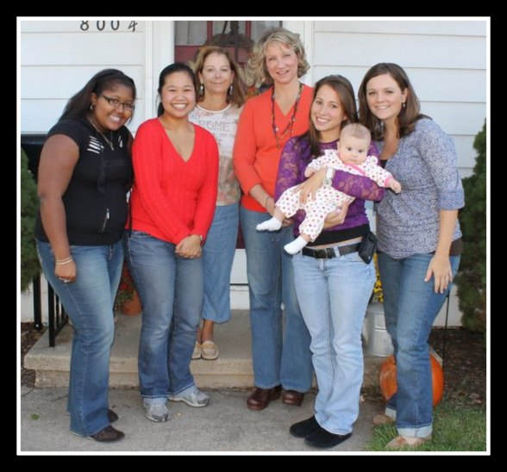
On October 13th, six alumnae members met at Treasurer, Kirsten Heck’s house to share a glass of wine and eat chocolate while discussing the future of this chapter. These ladies collected and donated over 20 items to My Sister’s Place Women’s Center Wish List as part of their event. This program helps provide a safe, supportive environment where homeless women and their families can access housing, referrals, life skills training, and many other resources to achieve and sustain self-sufficiency.
These were some of the items that were collected:
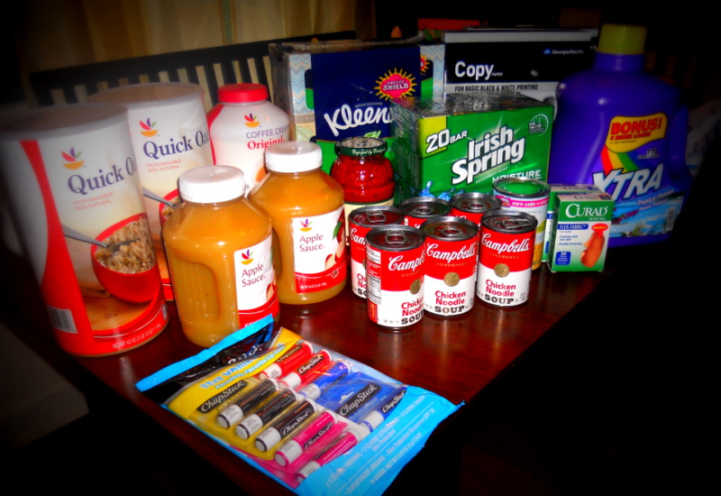
Stay tuned for updates on our latest events.

Sister’s Homemade Recipe
You must try these fall recipes, they’re absolutely delicious and easy to make.

Cheesy potatoes

-32 ounce bag of frozen hash brown potatoes (thaw & break apart)
-2 cups chopped onion
-2 cups shredded cheddar cheese
-1/2 cup melted butter
-1 can cream of chicken soup (not diluted)
-1 (16 ounce) carton of sour cream
-2 cups corn flakes

Mix all ingredients together except corn flakes and reserve 1/4 cup of melted butter. Place in 9 X 13 inch buttered dish/pan. Put 2 cups crushed corn flakes on top. Pour 1/4 cup melted butter on top of corn flakes. Bake 45 minutes at 350 degrees.
Serves 20 people.

Submitted by Angela Sorrem

The Rusty Scupper’s Sweet Potato Cheesecake Pie

-1 9-inch graham cracker pie shell
-1 tablespoon vanilla
-1 12-ounce can sweet potatoes
-1 tablespoon vanilla
-1 pint heavy cream
-½ teaspoon nutmeg
-1 cup light brown sugar

Drain sweet potatoes. Place heavy cream in mixer with all the other ingredients. Beat until soft peaks form; add sweet potatoes. Mix until incorporated. Pour mixture into pie shell and place in refrigerator. Let set for up to two hours and serve with fresh whipped cream.

Submitted by Diane Raycob

Picture Caption - Use this style to type a description of a picture or illustration.
Subtitle - Use this style to type sub-headings in an article.
Sororities symbolize all that we wish to accomplish in our lives. Why we cling to them no one can explain, but in the end we are stronger for it.
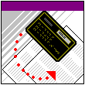
Anchored For Life
The Reason behind Staying Involved After College
After college, our lives only get busier but there is nothing like spending the afternoon with your sisters that can take a lot off your chest. Being a member of Alpha Sigma Tau makes you a part of a network that can be found anywhere around the world. So no matter where you go after college, you can always find an AST home to get involved in. If you are lucky, you will have 4 great years as a collegiate but 50+ unforgettable years as an alumna. So stay involved.
When you join Alpha Sigma Tau, it’s for a lifetime!! This is why you should stay active, not only with your local chapter but to get involved in a local alumnae organization in your own area. You are probably saying to yourself that you're over having to attend all the "mandatory" events and business meetings, and having to pay dues (which can be very expensive). However, joining an alumnae group is NOTHING like that! We meet about once or twice a month to just simply hang out, go shopping, participate in charity events, or to unwind and have a drink. None of the events are mandatory so you can come whenever you are available. Some events you can even bring friends, your spouse, kids, or family to. You can even take an office such as President, Vice President, Historian, etc which will continue to look great on your resume. Better yet, national dues for alumnae are $40 a year so you pay only once and you’re set!
The Baltimore Alumnae Chapter really takes pride in giving back to the community through serving lunch at Our Daily Bread, a Baltimore soup kitchen; building houses for Habitat for Humanity; sending treats and cookies to our deployed troops in partnership with the AST Stars and Stripes Alumnae chapter; collecting food and household items for the underprivileged families in the Baltimore area. Our chapter also gets involved in our local chapters in many different ways. For example, our chapter just started providing senior members with resources that will be helpful for life after college such as resume building, preparing for an interview, or job hunting.
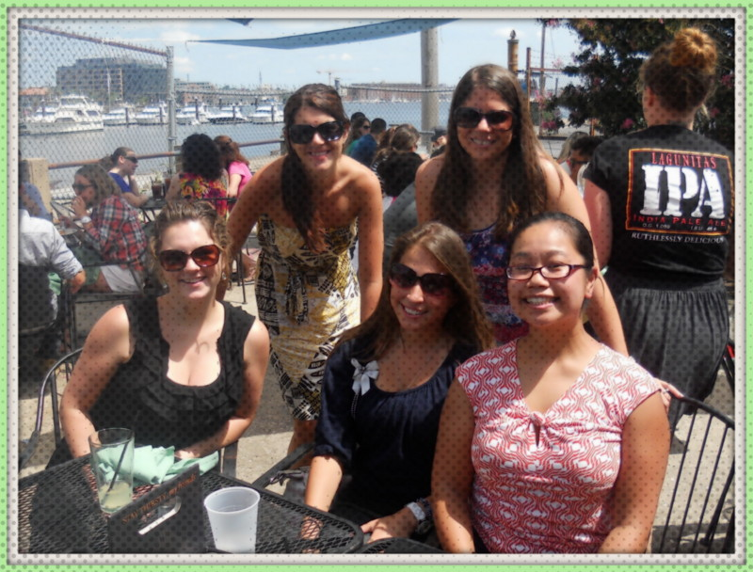
So get involved, it’s never too late to make a difference!
If you’re interested in getting involved, please contact our Alumnae-Collegiate Liaison, Jess Kromer at jesskromer@gmail.com
or check out our website at www.astbaltimore.org

Why I Joined AST?
Share Your Story!!

“I joined AST as a first semester sophomore. I was not quite a "never-joiner" - I was completely clueless, had no idea what Greek life was, had never even considered that sororities existed - it just wasn't in my frame of reference. I had met Heidi LaBelle Watts in choir as a freshman, while she was "pledging" herself to AST and fell in love with she and her friends - they became my friends and eventually my family.”
– Kirsten Heck, Treasurer

“I joined my freshmen year back in Fall 2008. I attended the formal recruitment event on campus. When I got to the AST table, I met a sister Tara Davisson who was very outgoing and genuine. Instantly, she wanted to get to know me and made me feel a sense of belongingness . After that night, I knew I wanted to be part of a sisterhood that would last a lifetime. Before I knew it Tara became my big sister and one of my best friends!! Alpha Sigma Tau has made a huge impact in my life...it was definitely one of the best decisions I ever made.”
– Jess Kromer, Alumnae-Collegiate Liaison

We Live Fantastic Lives
Pam Emory was extremely proud to send her son, Nick, off to Howard Community College in Columbia, MD. We hope he has a fanASTic freshman year!
Diane Raycob just retired from being a high school teacher for 34 years. She is currently president of the Joppatowne Woman’s Club and is also a member of Delta Kappa Gamma, a society for female teachers. During her career in VA and MD, she taught math and Latin, was a guidance counselor, and a facilitator (quasi-administrator). Gardening and cooking also keep her busy.
Katie McNulty, President, said “I Do” on July 21, 2012 to Neal Schenker. Congratulations Mrs. Schenker.
Kirsten Heck, Treasurer, gave birth to a beautiful AST legacy, Caroline Ann Heck, on June 18, 2012 Caroline is completely healthy allowing Kirsten to go back to work. She just celebrated her 3rd anniversary with Josh Heck. Congrats!!!
Jess Kromer, Alumnae- Collegiate Liaison, works full time as an assistant manager and community involvement coordinator for Walmart in Walkersville, MD. She also volunteers her time as the New Member Advisor for the Epsilon Nu Chapter at McDaniel College that was recently initiated in February.
Angela Sorrem just started teaching sign language classes in the evenings and is looking forward to the start of ski season.
Nazzie Spurrier, Social and Membership Director, just bought a new house in Reisterstown. Hope you get all settled in!

Newest Addition to Our Chapter
Nikia Patterson recently just graduated with a criminal justice degree from Fairmont State University. She joined the Delta Beta Chapter in Fall 2008. During her time there, she held many offices such as alumnae liaison, fundraiser, music, and philanthropy. Currently, Nikia works for City Bank in Hagerstown MD while raising her gorgeous daughter, Nila Rose. She joined AST “to be a part of something, because of the awesome girls, and to make friends that last a lifetime.”

continued on page 2

INSIDE THIS EDITION
1 | Anchored for Life
1 | The Joys of Sisterhood
2 | Why I joined AST?
2 | We Live Fantastic Lives
2 | Newest Addition to Our Chapter
3 | Calendar of Upcoming Events
3 | Sister’s Homemade Recipe
4 | What’s Going on With Our Collegiate Chapter
5 | Need Holiday Gift Ideas
5 | Contact US
continued on page 3
continued from page 1

Happy Birthday:
October 17th – Pam Emory

November 5th – Joell Sperry

Hope you have a fantASTic day!!
Calendar of Upcoming Events
Watch for your evite
Saturday, December 8th
Cookie Exchange

Location: Tina Tiley’s House
10217 Donleigh Drive, Columbia MD
Time: 2pm

Bring one batch of your favorite homemade holiday cookie. We’ll take turns sharing what makes our recipe special, and then divvy up the cookies. Kids are welcome to come!

Sunday, January
Souper Sunday

Location: Joell Sperry’s House
3082 Ebbtide Drive, Edgewood, MD 21040
Time: 2pm

What’s better on a cold winter day than a big bowl of soup? Come join us as we sample several varieties, and discuss new business for the new year. Soup will be provided.

Saturday, February 23rd
Happy Birthday To Us!

Location: Ciao Bella Restaurant
236 South High Street, Baltimore MD 21202
Time: 6pm

Join us for a dinner out in Little Italy at Ciao Bella. www.cbella.com

continued from page 1

What’s Going on with the Collegiate Chapters

Epsilon Nu
McDaniel College

“This semester we had many exciting things going on within our chapter. We recently went on a ghost tour and stayed at a campground in Gettysburg. It was a fun bonding experience for us as we learned to survive the thrills of camping for a night. Many of our sisters volunteered at Fall Fest in the local Westminster community for the Stacey Davis Breast Cancer Fund where we helped make scarecrows.
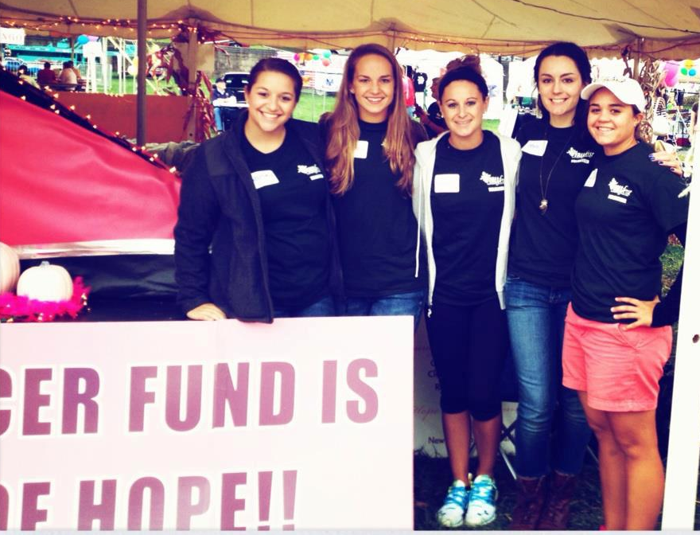

Also, we hosted an event called Sunday Funday, which included food, games, raffles, and a corn hole tournament. The money raised from this event went toward our national philanthropy, the Pine Mountain Settlement School. We continue to work with the Humane Society of Carroll County as well. Finally, we graduated 11 seniors in the spring. This fall during informal recruitment, we have welcomed 6 more lovely ladies into our sisterhood whom we are excited to get to know. Some of our recruitment themes consisted of ‘Fall in Love with AST’ and ‘In AST We Trust’ (red, white, and blue theme).” – Alise McNutt, Epsilon Nu Collegiate Alumnae Liaison

This chapter was recently founded this past year in February 11, 2012! So glad to have the Epsilon Nu Chapter as our sisters!

Being in a sorority is a gift that not everyone gets.

Psi Chapter
James Madison University

-8 sisters attended convention this past summer
-We were one of the chosen chapters to participate in the Pilot program workshops
-We are getting ready to host our philanthropy month this November. The theme will be "fall-anthropy month” to raise money for Pine Mountain. We are planning a 5K and various proceed nights at restaurants.
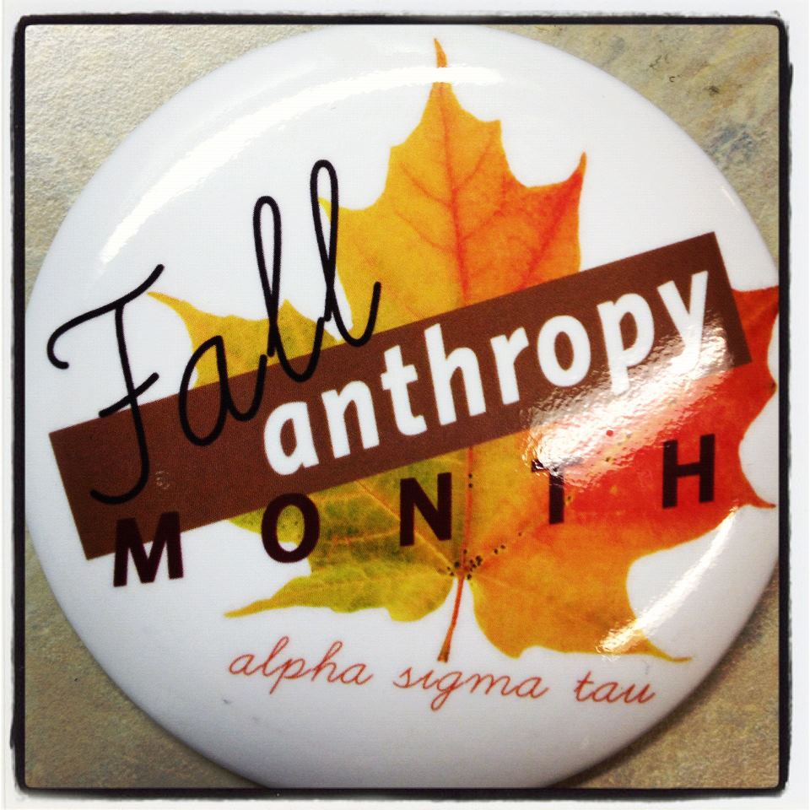
-We just elected our new President, VP, Treasurer, and New Member Educator
-We have been undergoing a lot of revamping to our academic system
- We are bringing David Stollman to campus to speak this fall
- We won a contest for $600 towards our philanthropy sponsored by new townhouse complex coming to campus, Aspen Heights
-Started a chapter blog, as well as a monthly newsletter we send out to Psi alumni

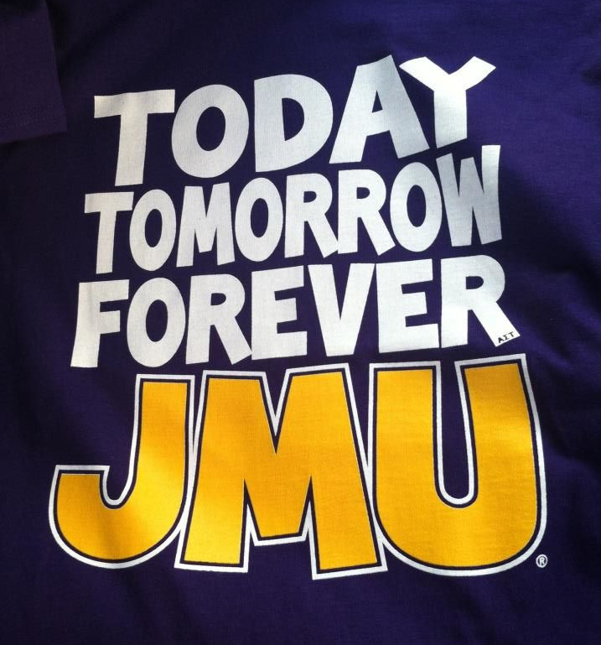

continued from page 5

Need Holiday Gift Ideas?
Don’t have time to shop for the perfect holiday gift….
Just go online to get exclusive offers on cookie dough and Restaurant.com eCertificates that can be sent as a gift. Also, you can purchase or renew subscriptions to their favorite magazines (like People, All You, TIME and Sports Illustrated) at up to 85% off. It’s super easy!!

Find the perfect gift today on: my.fundraising.com/BaltimoreAlumnaeChapter

Each time you make a purchase, we’ll receive up to 40% for our chapter. These funds will help support our programs by doing things like sending care packages to our troops, donating to the National Foundation and Pine Mountain, and supporting our local collegiate chapters. You can also support us by sharing this page and spreading the word to friends and family.

continued from page 4

Delta Beta
Fairmont State University

As our semester is quickly coming to an end, we remember all of our big accomplishments we take pride in. After our first recruitment event “Let our DynASTy be your destiny” we welcomed 6 great quality sisters into our chapter. Jacob Nelson, a brother of the Tau Beta Iota fraternity, was selected to be our Delta Beta AST Sweetheart for 2012-2013. During our homecoming week “Celebrate Now…Apocalypse Later,” we had 4 sisters and our sweetheart on the homecoming court.
In conclusion, we have been very active on- and off- campus. We have participated in numerous philanthropy events such as helping with the Halloween dance at the Disability Action Center, volunteering at the Humane Society, and collecting pennies for patients. One of our favorite sisterhood events was having a team to compete in zombie tag with other clubs on campus.

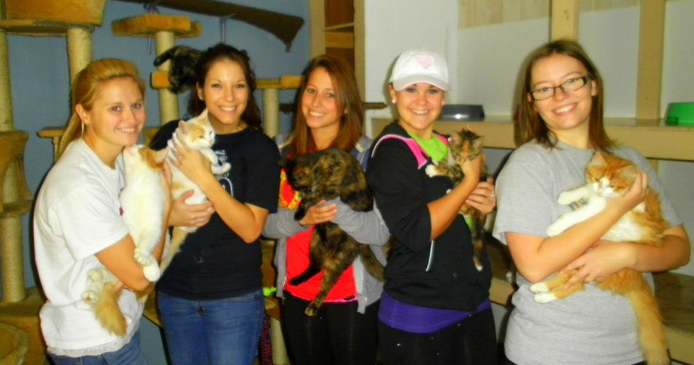

We are also proud to announce that Leanna William’s recently won Miss WV Turkey Festival Queen 2012.
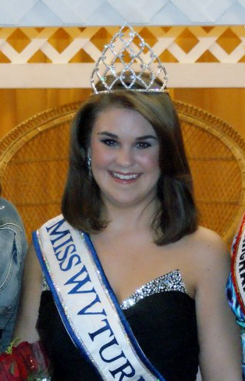

Contact US!
Interested in joining or want more information about our alumnae chapter:

Check out our website:
http://www.astbaltimore.org/

Follow us on Twitter: @ASTBaltimore

Follow us on Facebook:
Alpha Sigma Tau Baltimore Alumnae Chapter

Contact Jess Kromer, Alumnae-Collegiate Liaison:
jesskromer@gmail.com

Have you moved or got married recently?? Make sure you update your information with us by contacting Jess Kromer.

Volunteering at the Humane Society

