
Baltimore GazetTe
Volume 1, Issue 3 February 2013
Anchored For Life
When you join Alpha Sigma Tau, it’s for a lifetime!
Past National President, Patricia Simmons, revealed to us her story of how AST was always her destiny. She served as the past National President from 2002-2008. She currently works as a Development Officer for the Indiana University of Pennsylvania (her alma mater). In addition to being National President, she first served as the Chapter Adviser for the Delta Chapter then became the Zeta District President where she visited chapters in Virginia and North Carolina. However, her first experience on the National Council was when she ran for Director of Publications. She held that position for 3 terms while Martha DeCamp was President. Following DeCamp, Patti led the National Council for six years. Here is her story:
When and where did you join AST?
“I joined the Delta Chapter of AST at Indiana University of Pennsylvania in May 1970. My chapter had 63 members when I joined. How do I know that? Because I have the big composite hanging in my office here at IUP behind my desk!”
Why did you choose AST?
“I was a legacy of the chapter, as my mother- Joann Klausing, was an initiated adviser, so I guess I didn't have a choice. But I really did. I went through formal recruitment but loved AST. Additionally, my daughter is an AST, and my husband's great aunt, his aunt and cousin are all AST's! I knew early on that I wanted to join a Sorority. My dad was a football coach here at IUP and I would go to the football games and see the sorority girls there in their "dink's (a special hat they wore) and blazer's" and think that I wanted to be just like them!”
How has AST changed you?
“Alpha Sigma Tau has given me confidence and self-assurance. Believe it or not, I was a shy person in college. I learned how to speak in public and learned to do the job I do now!”
How do you manage to be so involved?
“I am a list person! I live with a list in my hand all the time. That is the only way I can stay organized!”
What was your favorite memory as AST National President?
“As president, I think my favorite memory was when I installed my very first chapter at St. Leo’s University, Delta Upsilon. I remember looking into the very first woman’s eyes and thinking ‘she is the first person I am initiating as President.’ I will never forget those eyes and I will never forget the feeling I had come over me.”
How many conventions have you been to? What was your favorite memory?
“I have been to 10-11. My first one was in Phoenix. And I went to the last one in Indianapolis. I even passed up a trip to Italy for my Sorority Convention!
My favorite memory is probably my saddest. We were in Ann Arbor at the Convention. I was Director of Publications and had just published the ‘Convention Daily’ late that night and was heading to bed. My roommate and I had just commented that we had not had any late night wake up calls with problems. I rolled over only to have the phone ring with my husband on the phone telling me that my sister had collapsed. I started thinking OK... I will be home Sunday, we can drive down to Morgantown and visit her then. He proceeded to tell me that she didn't make it. That is when you learn what Sisterhood is all about. My sisters rallied around me helping me find a flight home, helping me pack, helped me get to the airport, etc. And then, over the next week, I think I received a card, note and/or letter from every AST member at that convention. But we do have fun times at Convention! Last convention we filled our AST Executive Director's room with blow up pool toys! We love to stay up late and laugh and talk, as we may not see these members but every two year!
The highlights of conventions always include the candle-lighting, the opening and closing ceremonies, the singing of the Fraternity Hymn, and all the traditions. I still get goose bumps every time. Everyone needs to go at least once to experience it. Age makes no difference. Young or old, you can still have fun!”
What is a quote you live by?
“Dr. Seuss: ‘Don’t cry because it’s over. Smile because it happened.’
This quote is what I truly believe is what took me through my AST presidency. I could not believe it was over but was smiling that it actually happened.”
AST has changed so many lives. So stay involved, it’s never too late to make a difference!

INSIDE THIS EDITION
1 | Anchored for Life
1 | Making a Difference!
3 | We Live Fantastic Lives
3 | Why I Joined AST?
3 | Secrets to Interviewing Success
3 | Newest Addition to our chatper
4 | Calendar of Upcoming Events
4 | Sister’s Homemade Recipe
5 | What’s Going on With Our Collegiate Chapter
7 | Need Gift Ideas
7 | Contact US

Fiesta 5K for ALS Research

Making a Difference!
May 4, 2013, was a record-setting day for the Fiesta 5K. With your help, over 2,600 participants raised more than $410,000 to fight ALS, making 2013 our biggest year yet. Thank you for your help in making the event such a success. We appreciate the participation of Alpha Sigma Tau sisters, and are grateful for your support!

The Baltimore Alumnae Chapter is also pleased to have the honor of sponsoring a sister from the Epsilon Nu Chapter for the Hawaii Immersion Trip, through the Leadership Institute. Lindsey Rothrock was 1 of 15 sisters chosen for this opportunity in the country. Here’s what she wrote about this trip:
“A few weeks ago I was given the opportunity to participate in Alpha Sigma Tau’s, Service Immersion Trip in Hawaii. This Trip was a once in a lifetime opportunity and taught me so much. Not only did I learn how to excel as a leader I also learned how to be a better woman. Our group consisted of 15 amazing women, and all of which I know will be lifelong friends. I am so thankful for the opportunity I was given, and to all of those who helped me get there. I would like to encourage all collegian members to apply, and for all alumni to support this amazing trip.”

Stay tuned for updates on our latest events.
Sister’s Homemade Recipe
Having a cookout this summer? Check out these delicious recipes to make!

Cucumber Salad

4 medium cucumbers, peeled and diced
1 (8 ounce) container vanilla low-fat yogurt
1 (8 ounce) container reduced-fat sour cream
1/2 cup diced onion
2 cloves garlic, minced
1 tablespoon dried dill weed
Salt and pepper to taste

Drain cucumbers for a few minutes on paper towels. In a serving dish, stir together the yogurt, sour cream, onion, garlic, and dill. Add cucumbers, and gently mix to coat. Season with salt and pepper. Refrigerate for a couple of hours before serving for best flavor.
Makes 12 Servings.

Submitted by Diane Raycob

Caribbean Chicken Kebabs

1 ¼ lb skinless chicken breast fillets
Finely grated rind of 1 lime
2 tbsp fresh lime juice
1 tbsp rum or rum extract
1 tbsp light brown sugar
1 tsp ground cinnamon
2 mangoes
Rice and salad, to serve

Cut the chicken into bite-size chunks, and place in a bowl with the lime rind and juice, rum, sugar and cinnamon. Toss well, cover and leave to stand for 1 hour in a cool place.
Soak four wooden skewers in water for 20 minutes. Cut the mangoes into cubes by cutting slices, scoring into cubes and slicing away from the skin.
Prepare the barbecue. Position a lightly oiled grill rack over the hot coals. Drain the chicken, saving the juices, and thread on to the wooden skewers, alternating with the mango cubes.
Grill the skewers over high heat for 8-10 minutes, turning occasionally and basting with the reserved juices, until the chicken is tender and golden brown and the mango is slightly caramelized at the edges. Serve the kebobs immediately with rice and a salad.

Submitted by Jess Kromer

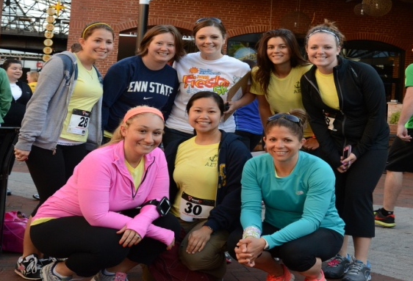
continued from page 1

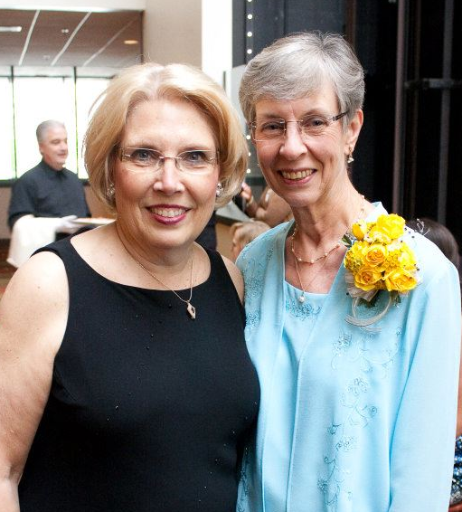
Photo of Patricia Simmons (on left) with Past National President, Martha DeCamp (on right)
We Live Fantastic Lives
Secrets to Interviewing Success
On April 13th, we travelled to the Beta Mu Chapter at Salisbury University where our alumnae sisters shared some interviewing tips for use after graduation. We covered topics such as making a great first impression, what to bring to an interview, what NOT to do during an interview, networking, the importance of invisible networking, cover letters, and interviews for specific majors such as education or photography. We also discussed the different types of interviews and sample interview questions. If you feel that your chapter could benefit from this presentation, we would love to come and share with you our secrets to a successful interview.

Newest Addition to Our Chapter
Alyson Wareing graduated Fairmont State University in May 2011 with a Bachelor in Business Administration. She joined the Delta Beta Chapter in fall 2008. Her favorite memory was the new member process and bonding with all the sisters. Currently, Alyson is a Federal Financial Aid Administrator for a 100% online university, called American Public University System. She just bought her first house and volunteers as a big sister with the Big Brother Big Sister Program. She loves to run for fun. She has run in the Tough Mudder, Warrior Dash, Color Run, and Local 5Ks for any cause. Alyson plans on doing a half marathon by the end of this year.

Diane Raycob adopted a puppy in January and named her Harper. She is full of energy--digging, chewing, playing and barking.
Katie got the assistant varsity field hockey and JV lacrosse coaching positions at Kent Island High School. Way to go! That’s awesome!
Alyson Wareing bought her first home and moved in!
Jess Kromer is a big sister to a 12 year old girl named Destiny as part of the Big Brother Big Sister Program. She has loved every minute of it. In addition, Jess also won her second pageant and now holds the Ms. WV Dandelion Festival Title.
Debi Meek celebrates being one year cancer free - praise God!
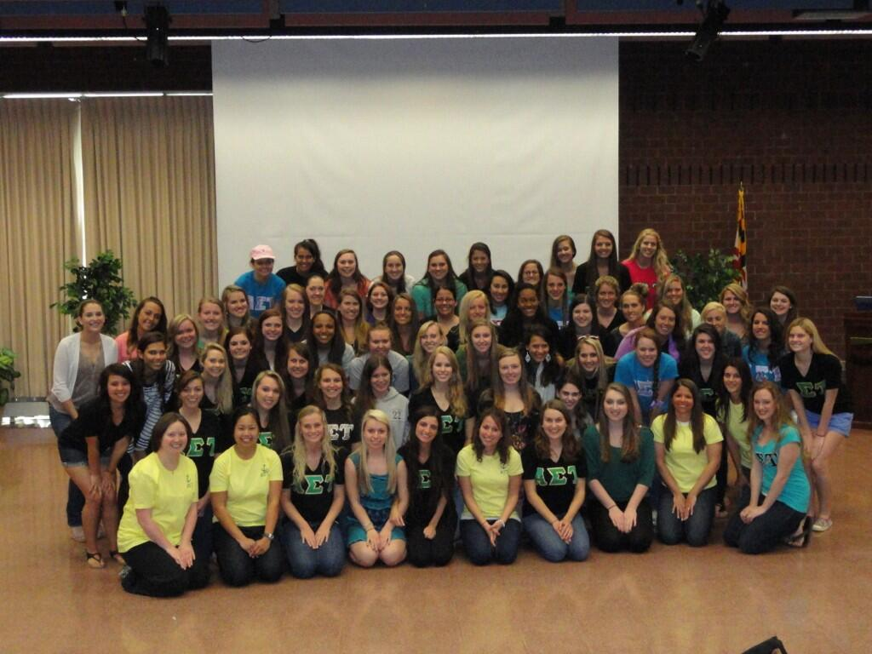
Lauren Hall and her husband, Danny will be celebrating their second anniversary together in Australia!

Why I Joined AST?
Share Your Story On Our Facebook Page!!
“I thought it was a great way to meet more people in college. And, I knew later on there would be an alumnae organization somewhere to continue to meet more great ladies.”
– Diane Raycob
“I joined AST because I wanted to be part of a group of friends with a purpose. I was always part of a team or club before college, but found it difficult to find something that I was interested in, somewhat organized, and of course fun. Through an AST classmate who was helping me with school work, I met a few other sisters and quickly knew that I was interested in the next formal recruitment. I learned about the purpose of each of the sororities at Salisbury University and while each one seemed interesting, the AST sisters looked like they were having the most fun and were the most genuine. I accepted a bid and it was the best decision I made throughout my entire college career!”
– Katie Schenker, President

Happy Birthday:
July 23rd – Nazie Spurrier

August 16th – Angela Sorrem

September 11th – Katie Schenker

October 17th – Pam Emory

Hope you have a fantASTic day!
Calendar of Upcoming Events
Watch for your evite
August 11th
Pool Party

Location: Pam Emory’s House
12902 Kentbury Drive, Clarksville, MD 21029
Time: 11:30 AM

Kick off the fall at this family friendly event! Burgers, hotdogs and beverages provided – bring a side dish to share, your swim suit and towel. Spouses, significant others, and kids are welcomed.

September 8th
Brunch on the Water!

Location: Little Havana Restaurant
1325 Key Highway, Baltimore MD 21230
Time: 11:30AM

What’s better than bottomless mimosas and bloody Mary’s on the water? Enjoying them with your sisters!

October 12th
Oktoberfest

Location: Diane Raycob’s House
710 Benjamin Road, Bel Air, MD 21014
Time: 4pm

Bring a 6-pack of your favorite premium beer for a tasting; refreshments provided. Families/Friends invited.

What’s Going on with the Collegiate Chapters

Epsilon Nu
McDaniel College

Spring semester brought about busy times for the Epsilon Nu Chapter. Formal recruitment was a huge success, and we were pleased to welcome 11 fabulous sisters into our chapter. We have enjoyed getting to know and bonding with our new sisters throughout the semester. A few weeks later, we hosted our 1st annual parent’s brunch and had big/little reveal all in the same day, so it was a very exciting day for us! The parent’s brunch consisted of time to share with our family while informing them more about our academic success and philanthropies, and we hope this is a tradition that will continue through the years.
Some philanthropy work that some of our sisters participated in this semester includes volunteering at a local MS walk, participating in an ALS walk in Baltimore, and creating a team at Relay for Life at our school. The end of the semester brought about Greek games and the Greek awards, both of which were very successful for our chapter. There were 3 days of games during Greek week including games in the quad, pool games, track and field, plus a day for Greek sing. Amazingly, AST had the highest amount of points after every day of events, which led to our chapter winning Greek games!

Epsilon Nu Continued….

This was a very exciting accomplishment for us! At the Greek awards event, out chapter brought home awards for outstanding Greek president, highest new member GPA, highest chapter GPA, and outstanding Greek athlete. The end of the semester also came with us graduating 10 seniors. It is sad to see them go, but we know we will always have our bond of sisterhood. This summer we had one of our sisters participate in the service immersion trip in Hawaii and our chapter was one of the ones picked for Recruitment Boot Camp in Indianapolis in June. We look forward to hearing about these amazing experiences in the fall!

Never accept minimum, always expect the BEST from your sisters!

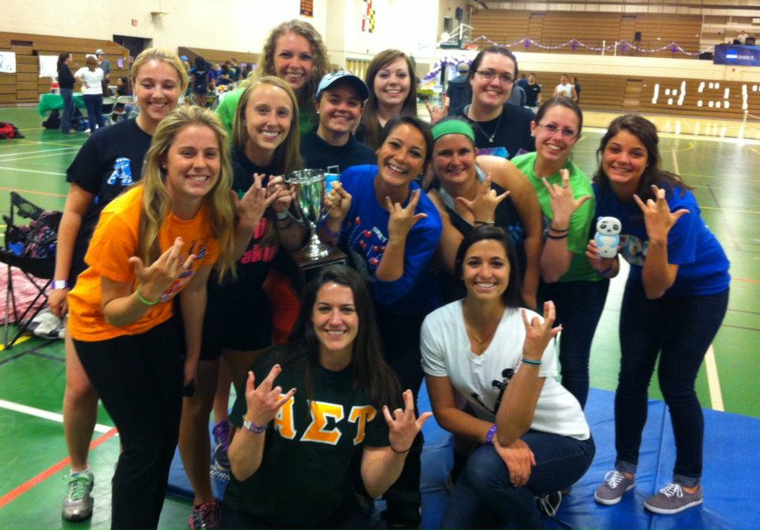

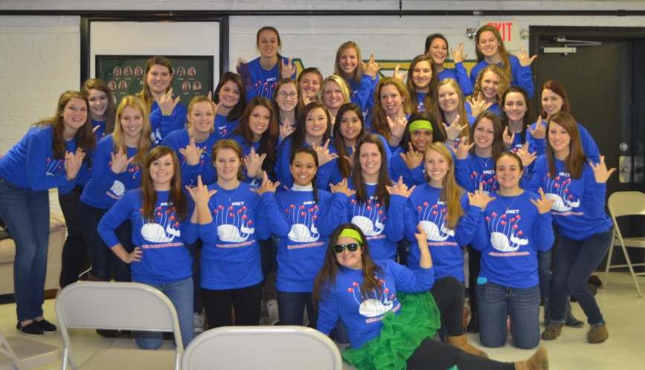

Delta Beta Continued…

We put up a good fight and received second place during Greek Week. We battled all week against the other sororities on campus in events such as pool volleyball, lip syncing, egg spoon race, three legged race, and corn hole. We are so proud of our sister’s teamwork!
We also competed in the Annual TBI Benefit Bowl where we battled once again the other sororities on campus in a game of flag football. All the money collected from this event was donated to a nonprofit agency.
Our sisters are also pleased to announce that we almost have a full advisory board. We are excited to have Holly Click, Recruitment Advisor and Megan Stivason, New Member Advisor join our team. With their help and having two sisters attend the Recruitment Boot Camp, we look forward to having a successful recruitment this fall and getting a large our new member class!

Delta Beta
Fairmont State University

This semester, the Delta Beta Chapter of wanted to focus on the importance of teamwork in both the formal setting of meetings and in all other aspects of life. Our chapter achieved our goal with flying colors.
During our recruitment this year, two lovely new sisters joined our chapter, Liana and Taylor. These two sisters are truly remarkable and down to Earth. We are so lucky to have them. Liana and Taylor fit the description of being Active, Self-reliant, and Trustworthy. They even reached out to our local Humane Society and donated several items during their new member process.

As a chapter, we have participated in numerous philanthropy events throughout the semester. We got our hands dirty volunteering at our local Habitat for Humanity and helped out at the Women’s Domestic Violence home. Three of our sisters volunteered during National Women Build Week in May for Habitat for Humanity.

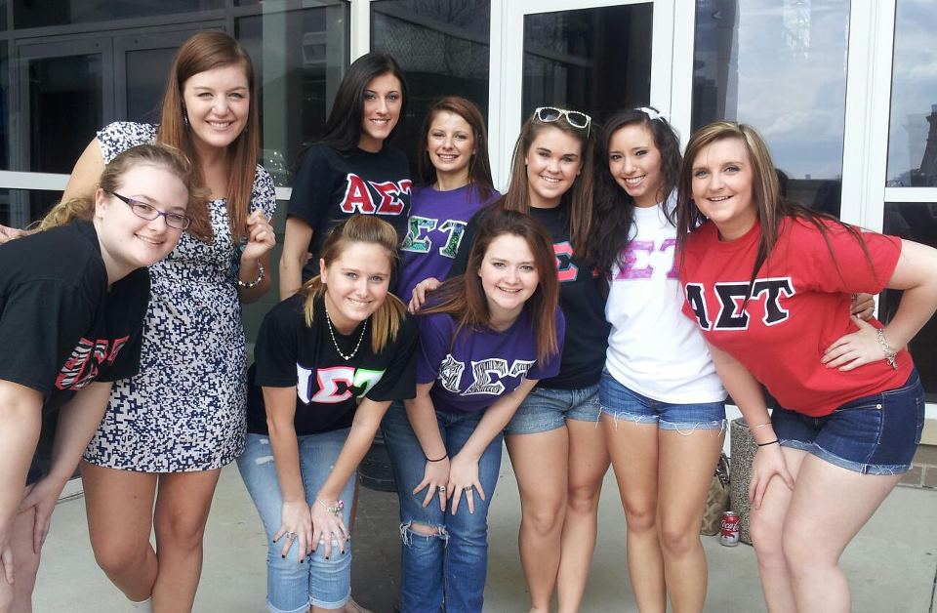

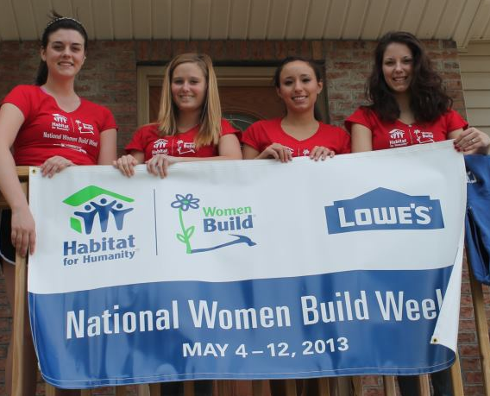
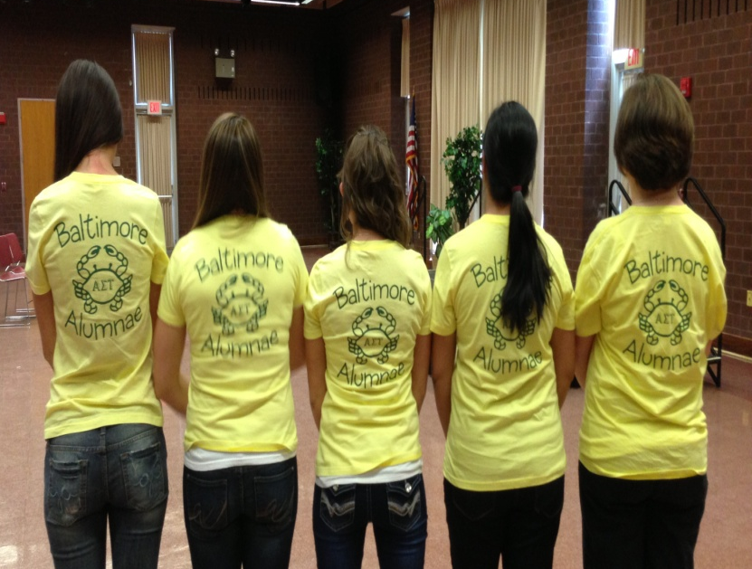

Need Gift Ideas?
Don’t have time to shop for the perfect wedding or birthday gift….
Just go online to get exclusive offers on cookie dough and Restaurant.com eCertificates that can be sent as a gift. Also, you can purchase or renew subscriptions to their favorite magazines (like People, All You, TIME and Sports Illustrated) at up to 85% off. It’s super easy!!

Find the perfect gift today on: my.fundraising.com/BaltimoreAlumnaeChapter

Each time you make a purchase, we’ll receive up to 40% for our chapter. These funds will help support our programs by doing things like sending care packages to our troops, donating to the National Foundation and Pine Mountain, and supporting our local collegiate chapters. You can also support us by sharing this page and spreading the word to friends and family.

Contact US!
Interested in joining or want more information about our alumnae chapter:

Check out our website:
http://www.astbaltimore.org/

Follow us on Twitter: @ASTBaltimore

Follow us on Facebook:
Alpha Sigma Tau Baltimore Alumnae Chapter

Contact Jess Kromer, Alumnae-Collegiate Liaison:
jesskromer@gmail.com

Have you moved or gotten married recently?? Make sure you update your information with us by contacting Jess Kromer.

