
Baltimore GazetTe
Volume 1, Issue 2 February 2013
Don’t Miss This Adventure!!
Join us Saturday May 4th for the Fiesta 5K put on by the Robert Packard Center for ALS Research at Johns Hopkins. All the money collected will go toward research to develop new treatments and a cure for ALS. This center is dedicated to researching this incurable disease and receives all its funding through private philanthropies
According to the Robert Packard Center, “Amyotrophic lateral sclerosis (ALS) – commonly known as Lou Gehrig's disease – is a progressive neuromuscular illness. In ALS, there’s a gradual, continuing degeneration of motor nerve cells in the brain (upper motor neurons) and spinal cord (lower motor neuron). When motor neurons can no longer send impulses to muscles, they begin to waste away (atrophy), causing increased muscle weakness and paralysis.
Currently, no cure exists for the disease, though patients treated at Johns Hopkins Multidisciplinary ALS Clinic have tapped into ways to keep the quality of life as high as possible.
Most people who develop ALS are between the ages of 40 and 75 although it can occur at a younger age. The disease is relatively rare; the incidence is roughly 2 people per 100,000 per year. Most surveys hold that ALS is more common in men than women, though that gap may be closing.” For more information, check out the website at:
http://www.alscenter.org/
Help support the cause by joining our chapter’s team “Alpha Sigma Tau – Baltimore” at www.fiesta5k.org .

Stay tuned for updates on our latest events.
Sister’s Homemade Recipe
Joell Sperry made these soups for our Souper Sunday Event in January! They were absolutely delicious so we had to share the recipes!

Turkey Cabbage Stew

1 lb ground turkey
1 medium onion, chopped
3 garlic cloves, minced
4 cups chopped cabbage
2 medium carrots, sliced
4 stalks celery, chopped
1 can (28 oz) diced tomatoes, undrained
1 tbsp. brown sugar
1 tbsp. white vinegar
1 tsp salt
1 tsp dried oregano
1/4 tsp dried thyme
1/4 tsp pepper
1 box (32 oz) reduced sodium chicken broth

Cook turkey, onion, and garlic in a dutch oven over medium heat until meat is no longer pink, then drain. Add remaining vegetables and sweat until cabbage is tender. Then, add the rest of the ingredients and simmer for an additional 10-15 mins before serving.

Butternut Squash Soup

2 tbsp. butter
2 small onions, chopped
2 stalks celery, chopped
2 carrots, sliced
2 green apples, cubed
1/2 large butternut squash, peeled & cubed
1 box (32 oz) reduced sodium chicken broth

Cook onions, celery, apples, and squash in a dutch oven until the squash starts to get tender. Add chicken stock and bring to a boil. Reduce heat to low and simmer for an additional 20-30 mins until the vegetables are tenderized. Blend with an immersion blender until smooth and enjoy! Some of the reviews suggested adding paprika or cayenne pepper for a kick, or serving with a dollop of sour cream.

Submitted by Joell Sperry,
Alumnae Panhellenic Delegate

Anchored For Life
The Reason behind Staying Involved After College
Remember all the excitement and thrill of wearing the letters across your chest, getting your big sister, or holding an office for the first time? All the memories you created while volunteering, recruiting, fundraising, and participating in Greek games with your sisters. Those memories will forever be a part of you and can continue to develop even after you walk across the stage on graduation day.
After college, our lives only get busier but there is nothing like spending the afternoon with your sisters that can take a lot off your chest. Being a member of Alpha Sigma Tau makes you a part of a network that can be found anywhere around the world. So no matter where you go after college, you can always find an AST home to get involved in. If you are lucky, you will have 4 great years as a collegiate but 50+ unforgettable years as an alumna. So stay involved.
When you join Alpha Sigma Tau, it’s for a lifetime!! This is why you should stay active, not only with your local chapter but to get involved in a local alumnae organization in your own area. You are probably saying to yourself that you're over having to attend all the "mandatory" events and business meetings, and having to pay dues (which can be very expensive). However, joining an alumnae group is NOTHING like that! We meet about once or twice a month to just simply hang out, go shopping, participate in charity events, or to unwind and have a drink. None of the events are mandatory so you can come whenever you are available. Some events you can bring friends, your spouse, kids, or family to. You can even take an office such as President, Vice President, Historian, etc which will continue to look great on your resume. Better yet, national dues for alumnae are $40 a year so you pay only once and you’re set!
The Baltimore Alumnae Chapter really takes pride in giving back to the community through serving lunch at Our Daily Bread, a Baltimore soup kitchen; building houses for Habitat for Humanity; sending treats and cookies to our deployed troops in partnership with the AST Stars and Stripes Alumnae chapter; collecting food and household items for the underprivileged families in the Baltimore area. Our chapter also gets involved in our local chapters in many different ways. For example, our chapter just started providing senior members with resources that will be helpful for life after college such as resume building, preparing for an interview, or job hunting.
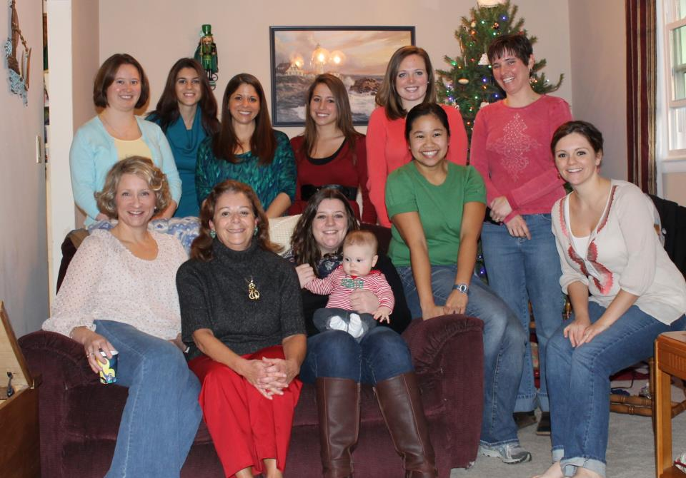
So get involved, it’s never too late to make a difference!
If you’re interested in getting involved, please contact our Alumnae-Collegiate Liaison, Jess Kromer at jesskromer@gmail.com or check out our website at www.astbaltimore.org

We Live Fantastic Lives
Pam Emory just got engaged on December 25th to David Siedling. Congratulations!
Ruby Marcelo just became a U.S. Foreign Service Officer. She hopes to be traveling the world soon.
Jess Kromer just joined the Society of Human Resources (SHRM) in Frederick and applied to be a big sister as part of the Big Brother, Big Sister Program.
Alyson Wareing just started her masters in business management with studied focus on organizational leadership. She also plans to run the Zombie Run in Harpers Ferry this year on March 23. Next on the list a Tough Mudder, Warrior Dash, Spartan Race and finally a half marathon in the fall.

Why I Joined AST?
Share Your Story On Our Facebook Page!!
“I had been involved in extracurricular activities in high school and was interested in getting involved in campus life when I went away to college. Getting involved was a chance for me to meet new people, to be active in the campus community, and to continue to develop leadership skills. But joining a sorority was not what I initially had in mind. Then two months into my first semester I happened upon an AST information night being held in my dorm. The Beta Mu chapter was an amazing group of young women… friendly, smart, funny, and committed to donating their time and energy to important causes. I was immediately interested in sorority life and joining AST. 25+ plus years later I'm still involved, as an alumnae member, and truly treasure my membership in AST.”
– Pam Emory
“In 2008, I joined a sorority to be part of something. What I found was a bunch of crazy, fun filled, enthusiastic, caring, amazing Alpha Sigma Tau sisters that always have my back. Life was not always about partying. I learned to balance my time for sure. We cried we laughed and we screamed together; I have tons of memories to last a life time and I wouldn’t change anything!”
– Alyson Wareing

Newest Addition to Our Chapter
Megan MacFeat went to Salisbury University and graduated in 2011 with a degree in Early and Elementary Education. She joined the Beta Mu Chapter in spring 2008. During her time there, she served as Panhellenic President. Last year, Megan became an Educational Consultant and travelled all over visiting collegiate chapters to advise and help them. She loved every minute! Now she lives in Baltimore where she goes to grad school at Loyola. She is also Recruitment Advisor for Epsilon Nu Chapter!

continued on page 2

INSIDE THIS EDITION
1 | Anchored for Life
1 | Don’t Miss These Adventures!
2 | We Live Fantastic Lives
2 | Why I Joined AST?
2 | Newest Addition to Our Chapter
3 | Calendar of Upcoming Events
3 | Sister’s Homemade Recipe
4 | What’s Going on With Our Collegiate Chapter
6 | Need Holiday Gift Ideas
6 | Contact US

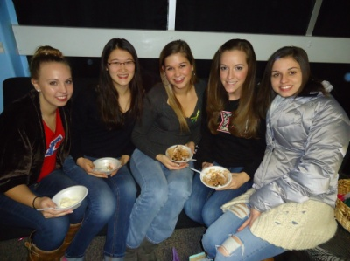

Some of the sisters of the Psi Chapter after an Ice Cream Social
continued from page 1

Happy Birthday:
January 25th – Kirsten Heck

March 6th – Megan MacFeat

March 15th – Jess Kromer

May 3rd – Diane Raycob

Hope you have a fantASTic day!
Calendar of Upcoming Events
Watch for your evite
March 10th
Ladies Afternoon

Location: Nazie Spurrier’s House
12213 Statewood Road, Reisterstown, MD 21136
Time: 2pm

Let’s lunch! Bring a light snack to share and a pack of diapers (any size, any brand) for My Sister’s Place, a shelter for women and children in Baltimore.

April 14th
Collegiate Engagement Event

Location: Salisbury University
Time: 12pm

Meet and greet some of our local collegiate members and share your alumnae experience during our interviewing workshops!

Saturday, May 4th
Fiesta 5K!

Location: Power Plant LIVE!
34 Market Place, Baltimore MD 21202
Time: 8AM

Wear your letters and run or walk with the AST team in the Fiesta 5K to support research at the Robert Packard Center for ALS. Registration is open – fiesta5k.org

Epsilon Nu
McDaniel College

“This semester is sure to be another eventful one for our chapter. We are looking forward to the one year anniversary of our installment on campus coming up on February 11th. It is so exciting to see all that we have accomplished in only one short year, knowing that all of our hard work has paid off tremendously. Formal recruitment is right around the corner as well, as we prepare to welcome more ladies into our sisterhood. During rounds for recruitment we will be wearing our favorite letters one night to express who we are as a sisterhood, and a monopoly theme is planned for the financial night.
A big event for us this semester is the hosting of Mr. McDaniel. This event consists of a few males competing in a pageant-like event to see who will be crowned the ultimate Mr. McDaniel. This is one of our biggest fundraisers for the spring semester, and it has become a tradition for us to host. Another event that we are in the processing of planning is a day for our parents. We want to have a special day where we can spend time with our parents and give them the chance to see what our chapter stands for both on and off campus.”

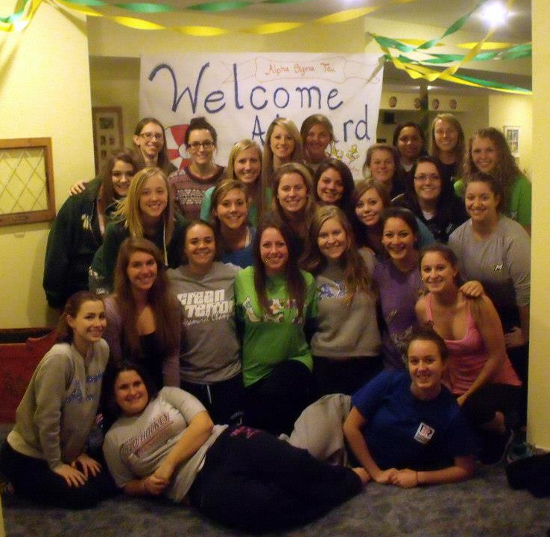

When sisters stand shoulder to shoulder, who stands a chance against us?

What’s Going on with the Collegiate Chapters

Gamma Zeta
Frostburg University

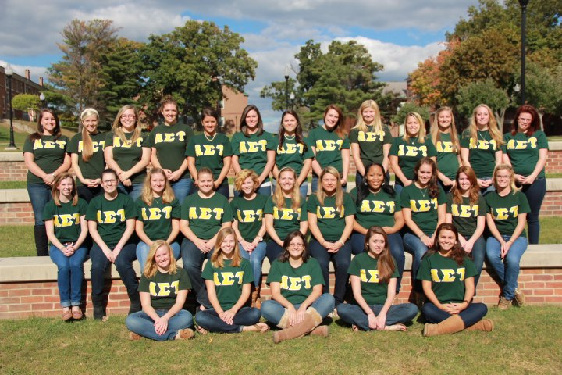

“Greetings! From the Gamma Zeta chapter of Alpha Sigma Tau, in Frostburg, Maryland! Thank you for reaching out to us and including us in your newsletter this month, we are honored! We have been very busy over the past year and have grown tremendously as a chapter. In the fall of 2012, five beautiful new girls joined our sisterhood, which made us at capacity of 50!
We had an on campus event this semester where we raised over $400 for the Troops overseas, and we also had 5 sisters go to Arlington National Cemetery this Christmas season and help participate in Wreaths across America! Four of our lovely sisters traveled to the beautiful New Orleans, Louisiana for a week over winter break to volunteer on a service trip through the school. While down there they each completed over 20 hours of volunteer work building houses for Habitat for Humanity, and working at an animal shelter.
This semester coming up we also have many awesome events we are preparing for such as Deep Creek Dunk, which raises money for the Special Olympics. As you can tell we have been a very busy chapter for the past year and are excited to be back together for the spring semester!”

Continued on to page 5

continued from page 4

Delta Beta
Fairmont State University

Alpha Sigma Tau means many things to many sisters and chapters. This semester, the Delta Beta Chapter of this great sorority wants to focus on the importance on teamwork in both the formal setting of meetings and in all other aspects of life. Our chapter is a small one, but numbers do not define what we are capable of. Although each of our members represents the motto of Alpha Sigma Tau with flying colors, our goal is to strengthen our teamwork.

This is important to us not only for recruitment, but also in community service, school work, and social aspects. We wish to improve our team cooperation to gain as many new members as possible that represent our sorority well, to take back the Greek Week Champion title, to win the annual TBI benefit bowl (a flag-football game played against all sororities and winners pick the charity to donate the winnings too), to support each other academically when we are struggling, and to never feel alone. I have no doubt that we can complete all these goals once we put our hearts and our heads together. TL&M <3

Continue from Epsilon Nu….
Lindsey Rothrock was selected to participate in the Hawaii Immersion Trip, through the Leadership Institute program this May. Only 14 AST sisters in the country have been chosen to partake in a seven nights and eight days adventure on the island of Oahu at YMCA’s Camp Erdman. Lindsey will be staying in a cabin on the beach where she will contribute four days of philanthropy service on the island. She gain knowledge from the women of The Leadership Institute in their new program called Project Impact. During her trip, she will also get the opportunity to participate in one of the world’s only double decker rope courses. Lindsey is an exceptional student who will also be studying abroad this semester in Budapest, Hungary. We look forward to hearing all about her trips when she returns in the summer. Best Wishes Lindsey! We know you will make us proud because you already do.

Beta Mu
Salisbury University

“Alpha Sigma Tau’s Beta Mu chapter at Salisbury University had a rewarding and prosperous fall semester. In September, we took part in the 3 mile walk to defeat ALS (Lou Gehrig's Disease) as well as the PJ Aldridge Foundation 3 mile walk/run for the fight against Lung Cancer in November. We are also hoping to participate in the walk/run for Multiple Sclerosis in April for the second year in a row.
In addition to our efforts to raise money for diseases, we are striving to make a difference for the environment and Go Green. Each chapter meeting we collect spare change in order to raise money to help bring clean water to children in need and have collected enough money to provide sanitary water to over 1,000 children! This semester we plan to have a week long event of Go Green activities to spread awareness and get the campus involved. We’re looking forward to recruitment in February and welcoming our new members to the AST sisterhood.”

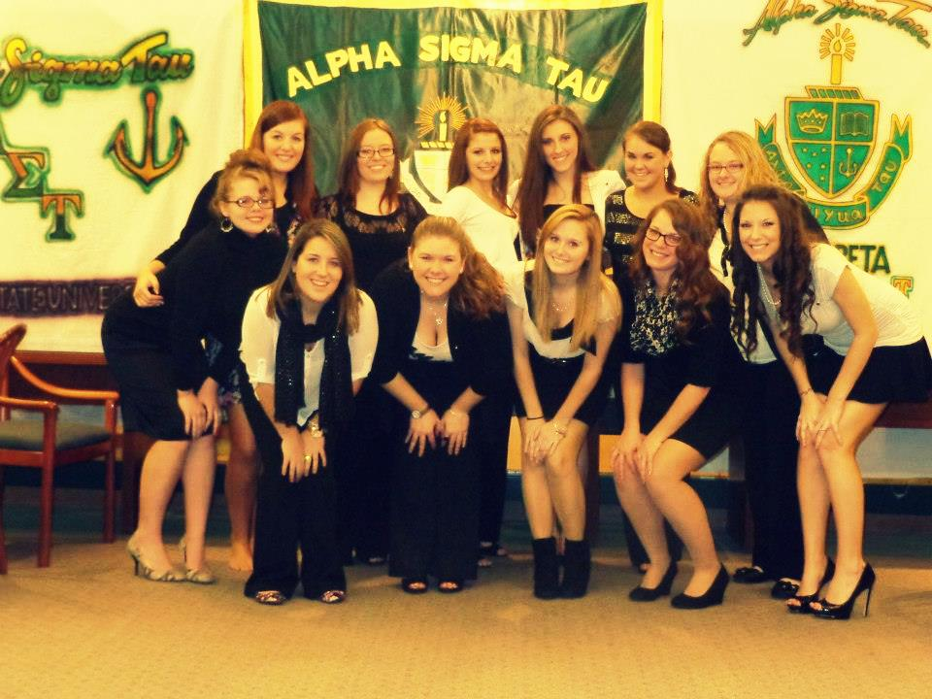

Psi Chapter
James Madison University

This semester, the Psi Chapter at James Madison University has been adding many new traditions to its chapter, as well as fostering the old ones. With a chapter of about 160 girls, we saw the need to revamp how we take attendance at chapter. We decided to create “Pearl Groups,” which are composed of about 10 members per group, chosen at random, that sit together during chapter in order to get to know each other on a deeper level. We believe that this will help new members get to know sisters better, as well as reduce the long lines we used to have before chapter, since now Pearl Group Leaders would be the ones in charge of their group’s attendance. We also revamped our weekly publicity day, Tau Tuesday. Now, every tuesday our sisters wear letters in order to promote AST on campus, and Tweet a picture of them in letters, along with the hashtag #tautuesdayAST, in order to promote our presence online. Also every Tuesday, our Psi chapter blog is updated with a new fun post that our sisters always love to read.
We have also added some new things to honor our alumnae! We are currently planning an alumnae brunch to celebrate our seniors becoming inducted into alumnae later in the spring. All alumnae and active sisters are invited! We have also created a new website for alumnae news, apparel and pictures. Keeping up with old traditions, on February 17th we are hosting our annual Mr. Fraternity Pageant to raise money for Juvenile Diabetes Research Foundation. We are also having our annual Parents Banquet in March, at the Stonewall Jackson Hotel in Staunton, VA. We have welcomed 7 new members this semester; they will be having a new member retreat in order to get to know each other better! We hope that our members, old and new, will appreciate and enjoy all the traditions that year after year bring us everlasting memories.
Check us out at: http://jmuastalumnae.wikispaces.com/home and http://astatjmu.blogspot.com

Need Gift Ideas?
Don’t have time to shop for the perfect wedding or birthday gift….
Just go online to get exclusive offers on cookie dough and Restaurant.com eCertificates that can be sent as a gift. Also, you can purchase or renew subscriptions to their favorite magazines (like People, All You, TIME and Sports Illustrated) at up to 85% off. It’s super easy!!

Find the perfect gift today on: my.fundraising.com/BaltimoreAlumnaeChapter

Each time you make a purchase, we’ll receive up to 40% for our chapter. These funds will help support our programs by doing things like sending care packages to our troops, donating to the National Foundation and Pine Mountain, and supporting our local collegiate chapters. You can also support us by sharing this page and spreading the word to friends and family.

Contact US!
Interested in joining or want more information about our alumnae chapter:

Check out our website:
http://www.astbaltimore.org/

Follow us on Twitter: @ASTBaltimore

Follow us on Facebook:
Alpha Sigma Tau Baltimore Alumnae Chapter

Contact Jess Kromer, Alumnae-Collegiate Liaison:
jesskromer@gmail.com

Have you moved or gotten married recently?? Make sure you update your information with us by contacting Jess Kromer.

